C.V
- Personal data
Name | Mohamed Said Moustafa Soliman
Date and place of birth | 15/3/1971- Giza-Egypt
Previous job | Hepatologist and Transplant Hepatologist  King Fahad Specialist Hospital Dammam
Current job | Assistant professor of Gastroenterology and Hepatology, Faculty of Medicine, Benha University, Egypt
Academic degree | M.D
Phone | -Mobile: +01028104021
Email | Mohsaed2006@yahoo.com, mohsaed2006@gmail.com
Recent Photo (passport format) | 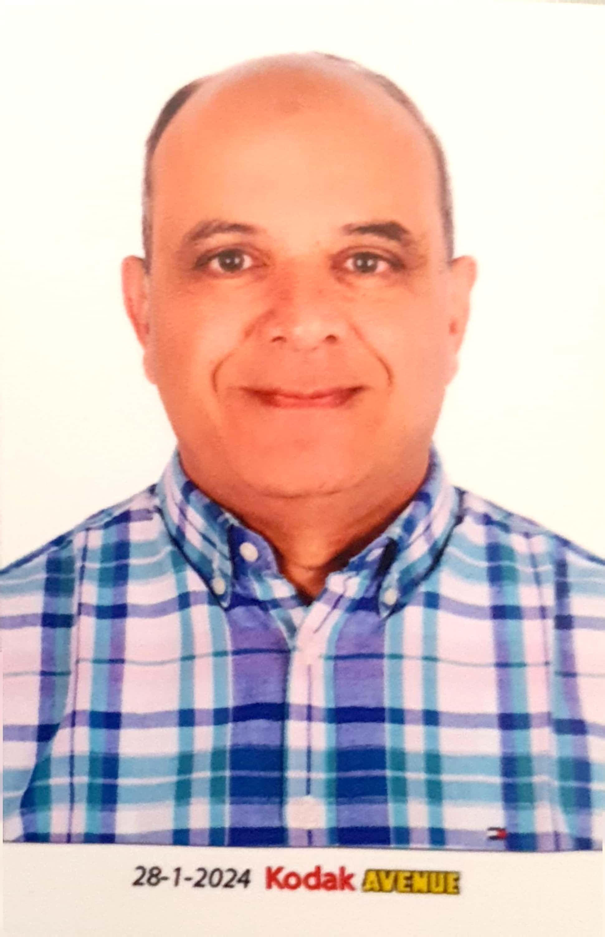

- Education
Institution | Degree obtained | Year
Zagazgig University-Benha,Egypt | MD in Tropical Medicine | 2006
Zagazgig University-Benha, Egypt | Master degree in Tropical Medicine | 2000
Zagazgig University-Benha, Egypt | MBBCh | 1995

General specialty | Medicine
Specific specialty | Hepatology and Gastroenterology

- Membership of professional bodies (List)

- A member of the American Association for the Study of Liver diseases (AASLD) since 2008 till now.
- A member of the Egyptian society of Hepatology, Gastroenterology& Infectious diseases since 1998
- A member of the Saudi association for the study of Liver diseases and Liver Transplantation since 2012
- Hepatology consultant at the Saudi Commission for Health Specialties
- Senior Hepatology and Gastroenterology consultant at the Egyptian Medical Syndicate

- Experience and areas of interest

- Liver diseases especially viral and autoimmune diseases, MASLD and other metabolic diseases, HCC, liver cirrhosis and its complications management.
- liver Transplantation: more than 12 years in the field of liver transplantation in one of the biggest centers in KSA, working in liver transplant evaluation, perioperative management including management of patients on the liver transplant waiting list and posttransplant care and management of its complications
- Gastrointestinal diseases: diagnosis and management of various GI diseases including gastroesophageal disorders, IBS, IBD, biliary and pancreatic disorders.

- Clinical research:

I have important publications in the field of Gastroenterology, hepatology and liver transplantation in well-known Journals like Annals of surgery and Digestive Disease science and abstracts in the biggest conferences in the field like AASLD, DDW, EASL and ACG.
Research Hepatology fellow in Cleveland Clinic- Ohio USA 2008-2009

- Skills:

- Endoscopy:

Diagnostic and therapeutic upper and lower endoscopy

- Liver Ultrasound:

Diagnosis of hepatic disorders like cirrhosis, MASLD, portal hypertension and hepatic focal lesions as well as biliary disorders.

.

- Positions
 | Date  From - to | Organization | Country | Position
1 | 8/1/2012 till August 2024 | King Fahd Specialist Hospital Dammam | Saudia Arabia | Hepatologist and transplant hepatologist
2 | 29/9/2011 till present | Faculty of Medicine, Benha University | Egypt | Assistant Professor of hepatology and gastroenterology
3 | March 2006 till 29/9/2011 | Faculty of Medicine, Benha University | Egypt | Lecturer of hepatology and gastroenterology
4 | 2002-2006 | Faculty of Medicine, Benha University | Egypt | Assistant lecturer of hepatology and gastroenterology
5 | 1997-2000 | Benha University Hospitals | Egypt | Resident of hepatology and gastroenterology
6 | Nov. 2008-July 2009 | Cleveland Clinic | USA | Research Hepatology fellow
7 | 2000-2008 | Wady El-Nile hospital- Cairo | Egypt | Specialist of Medicine and gastroenterology

